Ideation Phase
Define the Problem Statements

Date | 22 June 2026
Team ID
Project Name | Metro Ticket Generating System in ServiceNow
Maximum Marks | 2 Marks
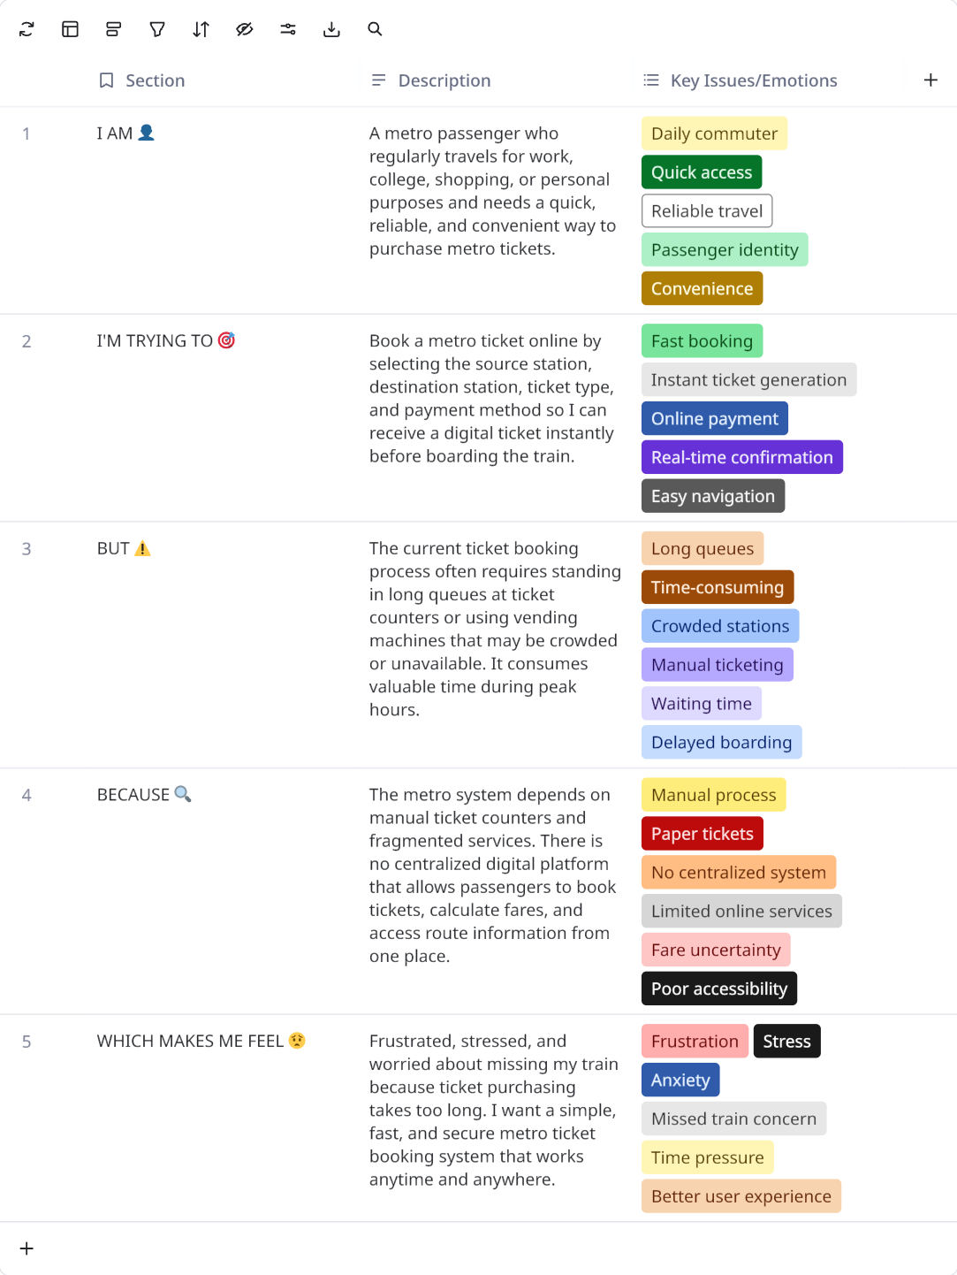

Reference: https://miro.com/templates/customer-problem-statement/
Problem Statement (PS) | I am (Customer) | I’m trying to | But | Because | Which makes me feel
PS-1 | Metro Passenger | Book a metro ticket quickly before my journey and receive a digital ticket instantly. | I have to wait in long queues at ticket counters or ticket vending machines, especially during peak hours. | The current process is mostly manual and there is no centralized online booking and ticket generation system | Frustrated, Stressed, Worried about missing my train..
PS-2 | Metro Ticket Administrator | Manage stations, routes, fares, ticket types, and monitor ticket bookings efficiently. | Updating fare details, routes, and booking information manually is time-consuming and prone to errors. | The information is maintained across multiple records without an automated centralized workflow | Overloaded, Concerned about data accuracy, Less productive.

